Initial Design plan  
Rendezvous Café Website

Web programming I - Assignment I

Presented to

Marissa Cleroux

By

Jeanne Tandoc

420-H10-HR GR. 00002

Cegep Heritage College

October 6th, 2023

**(Note: Please don’t deduct points from this pls!! But when I open the site from index file in my folder, some images don’t appear. It works fine with live server in VS code. I only noticed really late. I tried fixing it using the internet but nothing worked. So please open it with VS code 🙁 Pretty please )**

**Rendezvous Café**

Rendezvous Cafe is a shop that serves up a variety of coffee and different types of beverages, an assortment of pastries and desserts, and light meals as well as giving a relaxing space to lounge in. We try our best to listen to customer ideas (as well as our own staff)’s ideas on how to improve. As of late, we now do exciting giveaways and fun karaoke nights.

**What is the website for?**

I would like people to get a glimpse or feel of my business without actually having been inside the shop before. Additionally, the website is useful for all information regarding our shop (e.g, our menu, opening/closing hours). Our staff should already know all necessary details and would gladly inform customers about us but people not from the area/tourists or even people just looking for a place to eat would greatly benefit from having the website. In short, it’ll be used to determine what kind of business we are.

**List of pages**

* *Home:* The initial page you view once you click the website. If we have any new promotional offers or exciting events/news, it will be on Home. Also, a brief description of our business.
* *About us:* This page will talk about what started this business, the business owners, our history and our values.
* *Menu:* This will showcase the items that are sold on Rendezvous’s menu. From all the beverages, desserts to the light meals we craft.
* *Contact:* This will enable customers to be able to reach us for whatever reason they need. Like if they want to recommend a new menu item or if they have any questions.
* *Locations:* The location of stores and any new upcoming locations.
* *Store Hours:* The opening and closing times of our stores.

**Target Audience**

Rendezvous Café is a plant filled and bright Café hosting a lively yet relaxing atmosphere. Ideally, we want people of all ages to enjoy our shop. But I'm predicting the age range for the use of our website to be around 14-65 years old. I believe any younger than that would have interest in other things or wouldn’t have the necessary income to spend and therefore wouldn’t bother looking at the website. And any older typically wouldn’t like to use the internet. Everything I just mentioned is based on assumption only.

**Colour Palette**

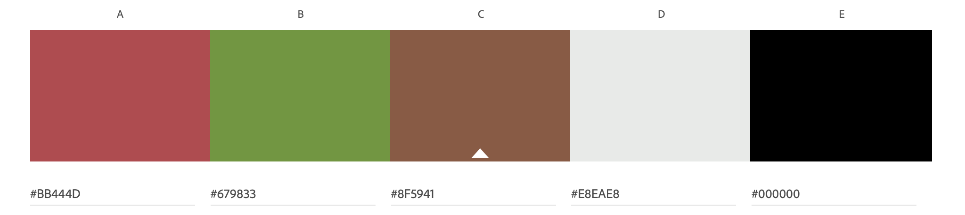

* ***Colour A:*** I’ll use this for decorational strips.
* ***Colour B***: An accent colour to brighten up the site and the font colour for the navigation.
* ***Colour C****:* I’ll use this for decorational strips.
* ***Colour D*:** Background colour for the other colours to lay nicely on.
* ***Colour E***: Mostly used for text.

**Logo**

(BrandCrowd logo generator, my friend had an account)

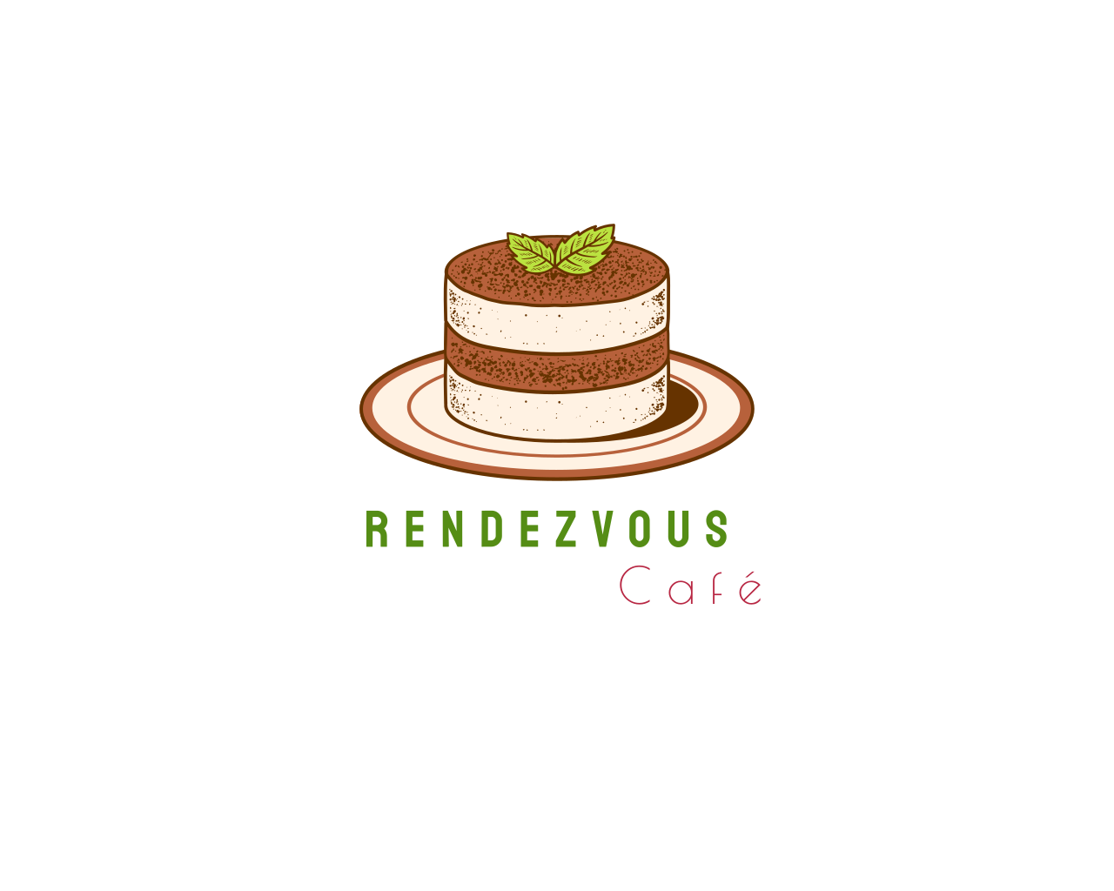

**Banner**

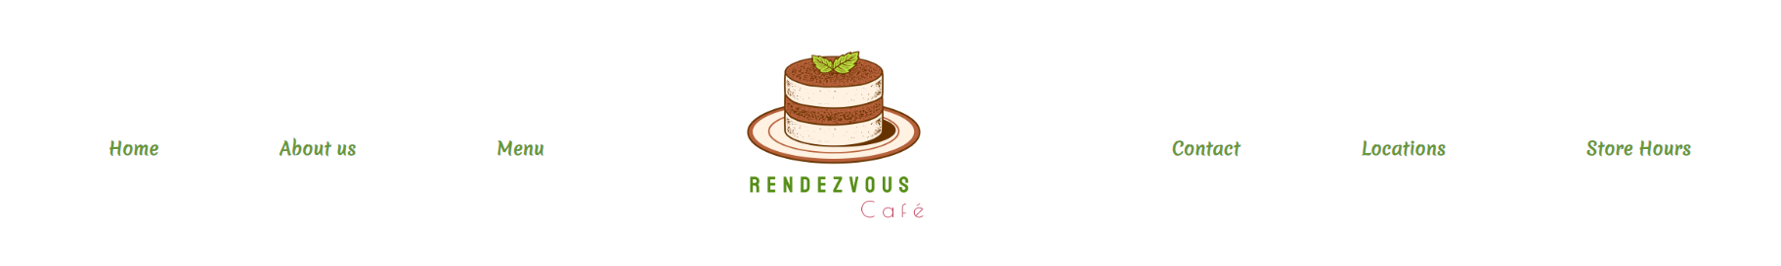

**Mobile Mock-up**

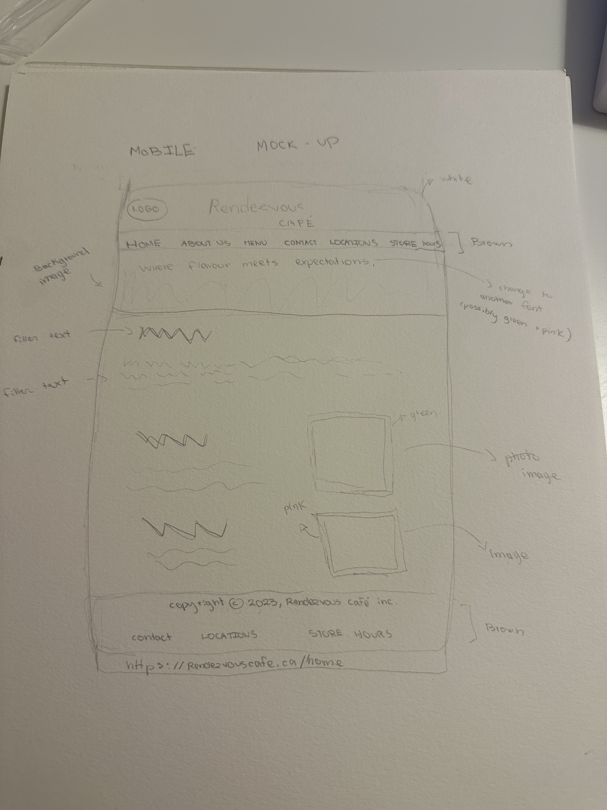

**Desktop Mock-up**